**BRM LAB FILE-3**

**Aim: Maven Build and usage in other Java Project**

1. Create a Build of java project using maven.
2. Use that build in some other Java Project.
   * + 1. -Created a java project ‘maven-demo’ using maven.

-Add a jar file to it.

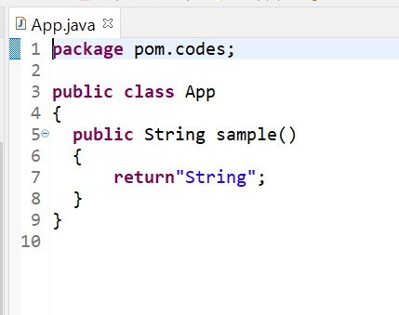

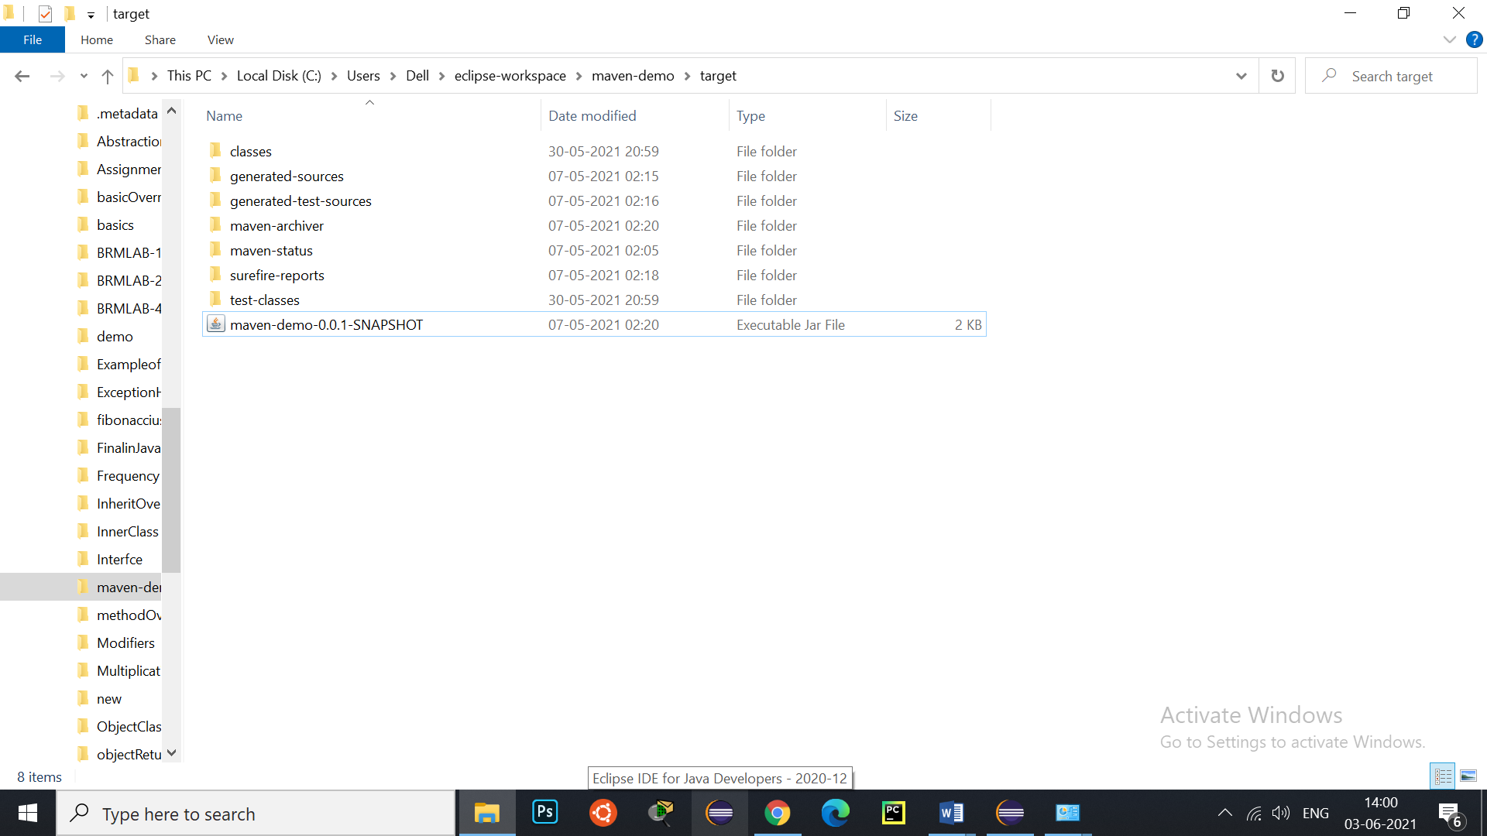

* + - 1. Now using this jar file in other java project ‘Read’.

